

**SCSJ3253**

**TEKNIK PENGATURCARAAN III**

**PROJECT**

Semester 1 2022/2023

**Lecturer’s Name:**

Prof. Madya. Ts. Dr. Mohd Shahizan Bin Othman

|  |  |
| --- | --- |
| **NAME** | **MATRIC NO** |
| SAVITH RAI | SX180279CSJS04 |
| NUR AINON BINTI YUSMADI | SX172096CSJF04 |
| SOBERY BIN BASRI | SX180091CSJS04 |
| MOHAMMAD HAFIZZUDDIN BIN MOHD ZIN | SX180405CSJS04 |

**Table of Contents**

1.0 Introduction 1

1.1 Objectives 2

1.2 Project Aim 2

1.3 Project Scope 2

2.0 Tools & Technology Used Description 3

2.1 Hardware Requirement 3

2.2 Network Requirement 4

2.3 Software Requirement 5

2.4 System Requirement Analysis 6

3.0 System Module and Module Functionality 7

4.0 Database Design 7

4.2 Entity-Relationship Diagram (ERD) 8

4.3 Use Case Diagram 9

4.4 Activity Diagram 10

4.5 User login and password 11

5.0 Achievement of Project Objective 12

6.0 Suggestion for future achievement 13

7.0 Conclusion 14

# 1.0 Introduction

Presently, a greater proportion of individuals are relying on the Internet as their main sources of information, particularly sport news. Most broadcasters operate their own web pages, which they update as soon as new information is made available. It has also emerged clear that such vast amounts of information are frequently too overwhelming for users to sift through in sequence to obtain the one bit of news those who are keen in Yahoo.com, for example, offer significant alternatives to the concern.

World Cup on the Go is an innovative but audacious digital magazine publications online platform and distribution center based in Kuala Lumpur with a Malaysian audience distributed throughout the country. As a sport news portal organization, we offer expertise in News, and Sports. Our cutting-edge in-house commentators are housed in a conventional corner piece facility located in the heart of Malaysia. "WorldCupOnTheGo.my" is an all-in-one Web-Application for publishers who want to run an online newspaper.

All content is stored within a database and classified. Classifications are easily customizable and have a self-organized interface for promoting top stories. Software can be managed using a role-based system similar to that of a traditional news article. The emphasis of a role-based framework to keep driving applications in secure mode is on page editors, managers, and assistance, among other things. The content schedule feature enables you to upload publications and news at a more convenient time. All articles on Media News Portal are created and published using optimized for search engines. URLs.

## 1.1 Objectives

The objectives of the project are:

1. A role-based sport news system that can be managed like a traditional newspaper.
2. To keep a consistent and well-structured website.
3. To create a website that is updated 24 hours a day, seven days a week.
4. To improve the quality of sport news delivered to users.
5. To create a directory and article search engine.

## 1.2 Project Aim

The goal of this project is to create a role-based system that will provide users with quality sports news 24 hours a day, seven days a week.

`

## 1.3 Project Scope

The three categories into which the project's scope can be divided are as follows:

a. Platform

1. This system is a web based system and c# as well as visual basic is used for the development of the web system.

b. Functionality

1. Subscribers can use the web system function to stay up to date on all sport news scores with pinpoint accuracy.
2. The website will be updated seven days a week, 24 hours a day.
3. This system will generate a directory and a search engine for articles.

c. Users

1. This system's users are our paid subscribers who are sports enthusiasts.

# 2.0 Tools & Technology Used Description

Tables 2.1, 2.2 and 2.3 are the details of hardware, network and software requirements for the development of World Cup on the Go systems.

## 2.1 Hardware Requirement

**Table 2.1** Hardware requirements for World Cup on the Go systems.

|  |  |
| --- | --- |
| Hardware | Justification |
| Laptop | |  |  | | --- | --- | |  | World Cup on the Go website systems are developed and tested on a laptop. The following are the laptop specifications:   * Processor :Intel® CoreTM i5-1135G7 * Hard drive : 160 GB minimum * RAM: 8 GB DDR4-3200 SDRAM | |
| Mouse | |  |  | | --- | --- | |  | The device is very important when it comes to computer accessories because it not only makes tasks simpler, quicker, and more convenient to complete. It can increase productivity among system developers because it operates more quickly, intuitively, and precisely than a mousepad. The mouse will be a Logitech. | |
| Keyboard | |  |  | | --- | --- | |  | The keyboard is the most well-known and frequently used input device for entering data in the form of text or numbers. They are incredibly effective, durable, and portable. We'll be using the enhanced keyboard, which has 110 keys. | |
| Monitor | A 20-inch DELL HDMI display will serve as the monitor |

## 2.2 Network Requirement

**Table 2.2** Network requirements for World Cup on the Go systems.

|  |  |
| --- | --- |
| Network | Justification |
| Network & Internet | Local area networks and wireless networks will be used as the main sources. One of the aforementioned network connections is required in order to access World Cup on the Go system |
| Firewalls & Defender | |  |  | | --- | --- | |  |  |   As a main source, the established firewalls as well as Windows Defender are not required to be changed since this system has been adequately developed so that these security features do not identify World Cup on the Go as a hazard. As the World Cup on the Go system does not necessitate any changes to the current setup during execution of the program, the local antivirus system would be permitted to function as well. |

## 2.3 Software Requirement

The software technologies used to construct the World Cup on the Go system are listed in Table 3.3 along with their justifications.

**Table 2.3** Software Requirements for World Cup on the Go system

|  |  |
| --- | --- |
| Software | Justification |
| Operating System | |  |  | | --- | --- | |  | Windows 10 (64 bits) or a later edition of Windows are supported. This Windows operating system is fast, dependable, and works with the majority of third-party devices and applications. | |
| Programming language | |  |  | | --- | --- | |  |  |   HTML, a standard markup language, was used to create web pages. HTML elements are used to design and structure sections, paragraphs, links, and other elements.  CSS is a simple design language which used improve the aesthetic appeal of web pages. It adds a new functionality to HTML.  The CSS Framework Bootstrap is well-known. It was used to build a web-based system that is responsive. It includes typography, forms, buttons, tables, and other design elements in HTML and CSS.  JavaScript is a dynamic programming language. It is lightweight and is most commonly used as a component of web pages, where its implementations allow client-side script to interact with the user and create dynamic pages (JavaScript - Overview, n.d.). It is an object-oriented interpreted programming language. (JavaScript - Overview, n.d.) Java script has several advantages, including richer interfaces, increased interactivity, and extended functionality. The web system was built using JavaScript. (JavaScript - Overview, n.d.)  C# is emphasized "C-Sharp". It is a Microsoft object-oriented programming language that runs on the.NET Framework.  C# has roots in the C group and is related to those other common languages such as C++ as well as Java. It is simple to comprehend and apply. C# is an object-oriented programming language that gives programmes a concise structure while also enabling code to be used again, reducing development costs. |
| Database | Microsoft SQL Server is a relational database management system, or commonly known as RDBMS. It is a software built on SQL, a standard programming language used to interact with relational databases.  SQL Server is linked to Transact-SQL, also known as T-SQL, which is Microsoft's SQL implementation that includes a set of proprietary programming constructs.  Among several other things, Microsoft SQL Server enables one to manage databases, relationships, tables, columns, indexes, permissions, and users. |
| Microsoft Visual Studio 2022 | Microsoft Visual Studio is an embedded development environment (IDE). It is utilized in the conception of computer programmes such as webpages, web apps, web services, and smartphone apps. Microsoft software development platforms such as Windows API, Windows Forms, Windows Presentation Foundation, Windows Store, and Microsoft Silverlight are used by Visual Studio. It can generate both native and managed code. |

## 2.4 System Requirement Analysis

The two fundamental components that comprise a system's necessities are both hardware and software. Numerous suitable and appropriate hardware and software are required for a rapid application development process in order to reduce labor costs and development time. The hardware and software requirements for developing the World Cup on the Go system are mentioned above.

# 3.0 System Module and Module Functionality

**Table 3.0** Use cases description of World Cup on the Go system

|  |  |
| --- | --- |
| **Use case** | **Description** |
| Login | This use case explains how user can login to the World Cup on the Go system after having the credentials made. |
| Check Content List | This use case describes how an administrator can add, update, edit, and delete sports-related content on the website page. This content is viewed by those who visit the website. |
| Check Team List | This use case describes the list of team member’s name that is active in a match. |
| Check Audit List | The audit section of the webpage is described in this use case. Audits are performed to ensure that the content is legitimate and up to date. |
| Logout | The sign out section is included in this use case. After using the system, both the user and the administrator can log out. |

According to the use case model displayed below, the system has six use cases, which each represents a particular module need. The following is a description of the use case in Table 3.0

# 4.0 Database Design

Using an Entity-Relationship Diagram (ERD) and normalized tables, this section outlines the data model for World Cup on the Go system. Match, Player, Post, Team, User and Audit are the database tables that are essential for the World Cup on the Go system. The main tables of the system's database are presented in Table 4.1.

**Table 4.1** Tables in database of World Cup on the Go system

|  |  |
| --- | --- |
| **Tables** | **Function** |
| Audit | Contain audit basic information |
| Match | Contain match scores information |
| Player | Contain player basic information |
| Post | Contain post information |
| Team | Contain team information |
| User | Contain user basic information |

## 4.2 Entity-Relationship Diagram (ERD)

An entity relationship diagram (ERD), often termed an entity relationship model, is a graphical depiction of the connections between the tables in a database's data model. Figure 4.7, includes an ERD diagram of World Cup on the Go system.

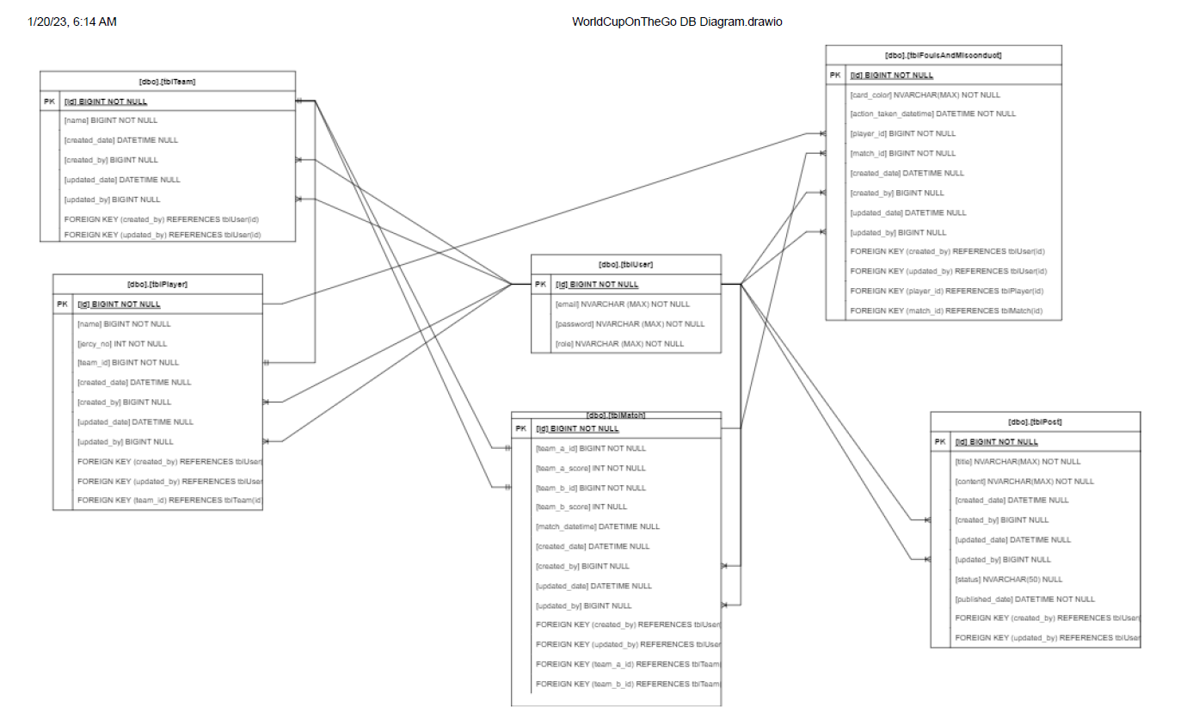

**Figure 4.2** ERD of World Cup on the Go system

## 4.3 Use Case Diagram

Figure 4.1 depicts the World Cup on the Go system's use case diagram. The main goal of the use case is to emphasize how the World Cup on the Go system functions as a whole. This use case provides a concise and accurate explanation of the system's behavior. The actor in the use case diagram is the user who will use the system to retrieve on demand unlimited sport news updates.

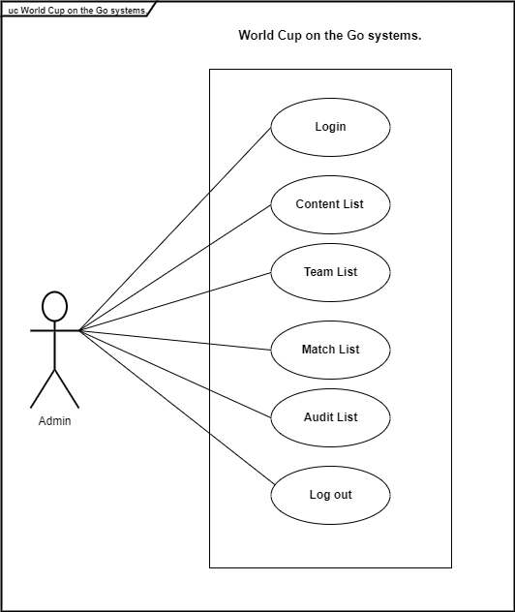

**Figure 4.3** World Cup on the Go Use Case Diagra

## 4.4 Activity Diagram

The operational step-by-step processes of components in the World Cup on the Go system are represented in the activity diagram flowchart. This section illustrates the activity flowchart of system, from the register for an account, User login and password for the system access to logout.

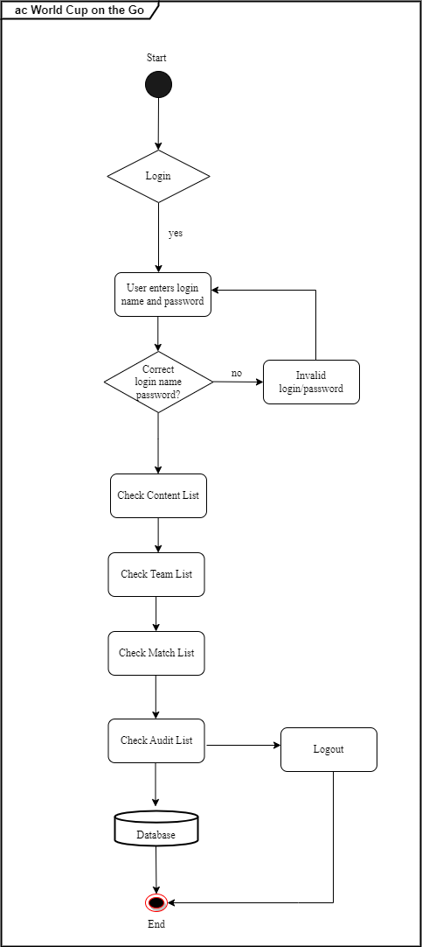

**Figure 4.4** World Cup on the Go system Activity Diagram

## 4.5 User login and password

This section explains how World Cup on the Go system user interfaces are designed, allowing for a better comprehension of the application. The User Interface (UI) is a component of a system that serves as a conduit between the user and the system, allowing the user to interact with it effectively. Because the World Cup on the Go system’s intended audience are all public users, an easy-to-use interface is necessary. The user interface is everything the end user interacts with physically, perceptually, and intellectually when using the system. As a result, the user interface design is design to be simple to grasp, consistent, and minimize users to make errors.

Following that, as shown in the illustration below, the user login and password for World Cup on the Go system access can be found. This set of credentials is used to gain access to the system's more prominent features.

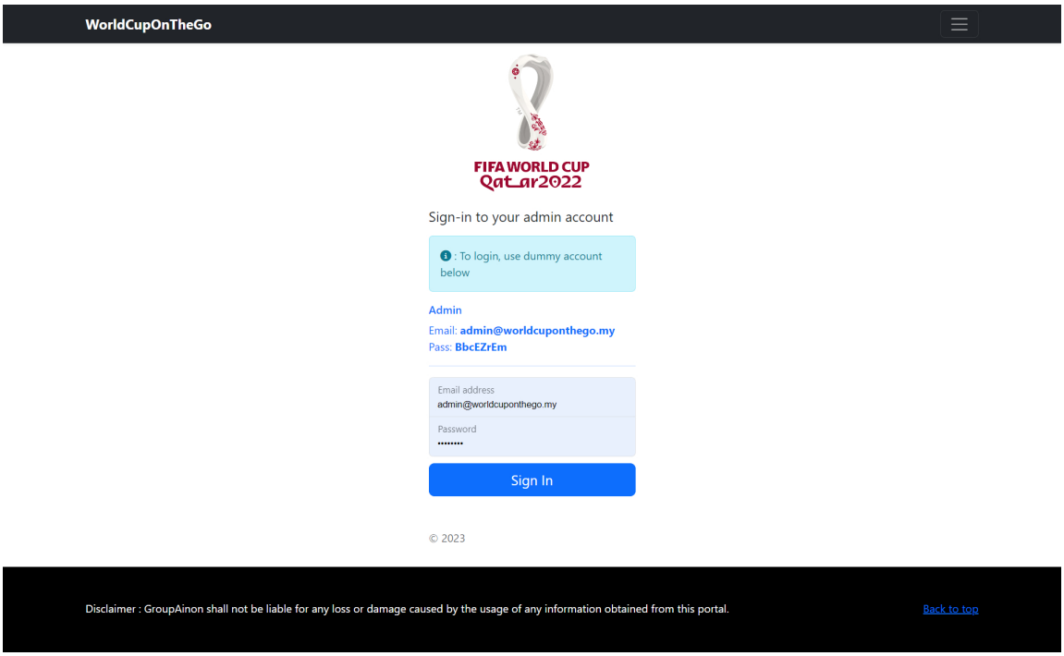

**Figure 4.5** World Cup on the Go system Dashboard

# 5.0 Achievement of Project Objective

The World Cup on the Go system project has successfully completed all of its objectives, as stated in project objective. The following is a list of the accomplishments:

* Appropriate open source algorithms for a role-based sport news system that can be managed like a traditional newspaper.
* To keep a consistent and well-structured website.
* The system's versatility that allows a website system that is updated 24 hours a day, seven days a week related all sports news.
* The system's novelty is to improve the quality of sport news delivered to users.
* The system's adaptability allows for the creation of a directory and an article search engine.

All of the features listed above are unique, as most World Cup on the Go system on the market are inaccurate, inefficient, and unable to save data to a database for further in-depth analysis, to create a directory and article search engine.

# 6.0 Suggestion for future achievement

Based on its limitations, a few suggestions have been made to improve the World Cup on the Go system. The following are some suggestions:

* Personalization allows users to keep up with their favorite sports, leagues, and teams.
* Top stories so that users can stay up to date
* Bookmarking capabilities allow users to keep track of their favorite stories.
* The interface is simple and easy to use.
* Search for videos and articles with enhanced search functionality
* Integration of the "Battle Draft" game, which makes the platform more enjoyable and keeps users on the platform longer.

# 7.0 Conclusion

In our project work, we attempted to create a news or information-based website. We created this project to assist people and make them aware of current affairs. We use a variety of methodologies to build this website.

All of the project's objectives have been fulfilled. Several challenges were encountered during the project's development. Nonetheless, the required actions and solutions were implemented. The supervisor gave effective supervision and directions in order to complete the task on time. This apart from that, the flaws of the project were highlighted. Finally, several suggestions and proposals for the future improvement of this system were recognized.